

April 17, 2025
Invite Involve Instruct Inspire
New Here? Wonderful! And welcome!
- Fill out a Connection Card. If you do…
  - We will pray for you by name this week.
  - You’ll get a handwritten welcome note from the clergy.
- Grab a What Is Going On Here? card from the tables outside the door. It explains much of what happens during worship and why.
- Clergy and lay volunteers are happy to answer any questions you might have.
Holy Communion: Share in the Body and Blood of our Lord Jesus Christ.
- Bread is offered first; wine second
- The first chalice is the common cup (sip directly). The second chalice is for intinction (the bread will be dipped).
- Let the clergy know if you need a Gluten Free wafer
Prayer Partners can be found at the back of the church during holy communion to personally pray for whatever is on your heart or mind.
Assisted Hearing Devices are available for those that would like one. Please ask an usher.
Crosses in the Bulletin? The crosses (✠) are placed in the text of the liturgy at times when it is customary to make the sign of the cross.
Giving: Thank you for your gifts!
- Offering plates are passed for in-person giving (cash and checks).
- Online giving is available and easy to do using the link and QR code below (cards).

Online Giving

give.standrewsmckinney.org
Maundy Thursday
Welcome
Once the Prelude begins, please refrain from further visiting and conversation as we prepare our hearts and thoughts for worship. Prayers before worship can be found in the Book of Common Prayer, p. 833-35.

Prelude

The Word of God

Please stand.

Processional
Come and Fill Communaute de Taizé
Come and fill our hearts with your peace.
You alone, O Lord, are holy.
Come and fill our hearts with your peace.
Amen.

Remain Standing

Opening Acclamation
Celebrant Blessed be God: ✠ Father, Son, and Holy Spirit.
People And blessed be his kingdom, now and for ever. Amen.

Almighty God, to you all hearts are open, all desires known, and from you no secrets are hid: Cleanse the thoughts of our hearts by the inspiration of your Holy Spirit, that we may perfectly love you, and worthily magnify your holy Name; through Christ our Lord. Amen.

Song of Praise
Within Our Darkest Night Communaute de Taizé
Within our darkest night,
you kindle the fire that never dies away

Please stand.

Collect of the Day
Celebrant The Lord be with you.
People And also with you.
Celebrant Let us pray.

Almighty Father, whose dear Son, on the night before he suffered, instituted the Sacrament of his Body and Blood: Mercifully grant that we may receive it thankfully in remembrance of Jesus Christ our Lord, who in these holy mysteries gives us a pledge of eternal life; and who now lives and reigns with you and the Holy Spirit, one God, for ever and ever. Amen.

Be seated.

The Scriptures: 1 Corinthians 11:23-26
I received from the Lord what I also handed on to you, that the Lord Jesus on the night when he was betrayed took a loaf of bread, ²⁴ and when he had given thanks, he broke it and said, “This is my body that is for you. Do this in remembrance of me.” ²⁵ In the same way he took the cup also, after supper, saying, “This cup is the new covenant in my blood. Do this, as often as you drink it, in remembrance of me.” ²⁶ For as often as you eat this bread and drink the cup, you proclaim the Lord’s death until he comes.

After the reading, the Reader will say
The Word of the Lord.
People Thanks be to God.

Psalm 116:1, 10-17
Read responsively.
I love the Lord, because he has heard the voice of my supplication,
because he has inclined his ear to me whenever I called upon him.
How shall I repay the Lord
for all the good things he has done for me?
I will lift up the cup of salvation
and call upon the Name of the Lord.
I will fulfill my vows to the Lord
in the presence of all his people.
Precious in the sight of the Lord
is the death of his servants.
O Lord, I am your servant;
I am your servant and the child of your handmaid;
you have freed me from my bonds.
I will offer you the sacrifice of thanksgiving
and call upon the Name of the Lord.
I will fulfill my vows to the Lord
in the presence of all his people,
In the courts of the Lord’s house,
in the midst of you, O Jerusalem.

Please stand.

Sequence Hymn
Bless the Lord, My Soul Communaute de Taizé
Bless the Lord, my soul,
and bless God’s holy name.
Bless the Lord, my soul,
who leads me into life.

Remain standing.

The Gospel: John 13:1-17, 31b-35
The Deacon or a Priest reads the Gospel, first saying
The Holy Gospel of our Lord Jesus Christ according to John.
People Glory to you, Lord Christ.

Now before the festival of the Passover, Jesus knew that his hour had come to depart from this world and go to the Father. Having loved his own who were in the world, he loved them to the end. ² The devil had already put it into the heart of Judas son of Simon Iscariot to betray him. And during supper ³ Jesus, knowing that the Father had given all things into his hands, and that he had come from God and was going to God, ⁴ got up from the table, took off his outer robe, and tied a towel around himself. ⁵ Then he poured water into a basin and began to wash the disciples’ feet and to wipe them with the towel that was tied around him. ⁶ He came to Simon Peter, who said to him, “Lord, are you going to wash my feet?” ⁷ Jesus answered, “You do not know now what I am doing, but later you will understand.” ⁸ Peter said to him, “You will never wash my feet.” Jesus answered, “Unless I wash you, you have no share with me.” ⁹ Simon Peter said to him, “Lord, not my feet only but also my hands and my head!” ¹⁰ Jesus said to him, “One who has bathed does not need to wash, except for the feet, but is entirely clean. And you are clean, though not all of you.” ¹¹ For he knew who was to betray him; for this reason he said, “Not all of you are clean.”
¹² After he had washed their feet, had put on his robe, and had returned to the table, he said to them, “Do you know what I have done to you? ¹³ You call me Teacher and Lord—and you are right, for that is what I am. ¹⁴ So if I, your Lord and Teacher, have washed your feet, you also ought to wash one another’s feet. ¹⁵ For I have set you an example, that you also should do as I have done to you. ¹⁶ Very truly, I tell you, servants are not greater than their master, nor are messengers greater than the one who sent them. ¹⁷ If you know these things, you are blessed if you do them.
³¹ “Now the Son of Man has been glorified, and God has been glorified in him. ³² If God has been glorified in him, God will also glorify him in himself and will glorify him at once. ³³ Little children, I am with you only a little longer. You will look for me; and as I said to the Jews so now I say to you, ‘Where I am going, you cannot come.’ ³⁴ I give you a new commandment, that you love one another. Just as I have loved you, you also should love one another. ³⁵ By this everyone will know that you are my disciples, if you have love for one another.”

After the Gospel, the Reader will say
The Gospel of the Lord.
People Praise to you, Lord Christ.

Be seated.

The Homily
The Rev. Andrew Van Kirk

Foot Washing
All are invited to the foot washing stations in order to have their feet washed and participate in the washing of others.
Ubi Caritas Communaute de Taizé
Ubi caritas et amor,
ubi caritas, Deus ibi est.

Stay with Me Communaute de Taizé
Stay with me, remain here with me,
watch and pray, watch and pray.

In God Alone Communaute de Taizé
In God alone my soul can find rest and peace,
in God my peace and joy.
Only in God my soul can find its rest,
find its rest and peace.

At the conclusion of the foot washing, all stand and the Celebrant and people say the following anthem
The Lord Jesus, after he had supped with his disciples and had washed their feet, said to them, “Do you know what I, your Lord and Master, have done to you? I have given you an example, that you should do as I have done.”
Peace is my last gift to you, my own peace I now leave with you; peace which the world cannot give, I give to you.
I give you a new commandment: Love one another as I have loved you.
Peace is my last gift to you, my own peace I now leave with you; peace which the world cannot give, I give to you.
By this shall the world know that you are my disciples: That you have love for one another.

Remain standing.

Prayers of the People
I ask your prayers for God’s people throughout the world; for our Presiding Bishop Sean, our Bishop George; for our clergy, Andrew, Logan, Paulette, Mike, Gene, and Erica; for this gathering; for all ministers and people; and for the ministries of this parish. Pray for the Church.
Silence

I ask your prayers for peace; for goodwill among nations; and for the well‑being of all people. Pray for justice and peace.
Silence

I ask your prayers for the poor, the sick, the hungry, the oppressed, and those in prison. Pray for those in any need or trouble.
Silence

I ask your prayers for the refugees being ministered to at Gateway of Grace, and for all refugees. Pray that they may find sanctuary and solace.
Silence

I ask your prayers for all who seek God, or a deeper knowledge of him. Pray that they may find and be found by him.
Silence

I ask your prayers for the departed ✠. Pray for those who have died.
Silence

Praise God for those in every generation in whom Christ has been honored. Pray that we may have grace to glorify Christ in our own day.
Silence

The Celebrant concludes with a suitable Collect.

Please kneel or remain standing.

Confession of Sin
The Deacon or a Priest says
Let us confess our sins against God and our neighbor.
Most merciful God, we confess that we have sinned against you in thought, word, and deed, by what we have done, and by what we have left undone. We have not loved you with our whole heart; we have not loved our neighbors as ourselves. We are truly sorry and we humbly repent. For the sake of your Son Jesus Christ, have mercy on us and forgive us; that we may delight in your will, and walk in your ways, to the glory of your Name. Amen.

The Priest says the Absolution.
Almighty God have mercy on you, ✠ forgive you all your sins through our Lord Jesus Christ, strengthen you in all goodness, and by the power of the Holy Spirit keep you in eternal life. Amen

Please stand.

The Peace
Celebrant The peace of the Lord be always with you.
People And also with you.

The Holy Communion

Be seated.

Offertory
Please place your offerings and Connection Cards in the offering plates as they are passed. You can also easily give online at give.standrewsmckinney.org.

Offering Music
Let all mortal flesh keep silence (vv.1-3) Picardy #324 (Hymnal 1982)

Please stand.

Doxology Old 100th
Praise God, from Whom all blessings flow;
Praise Him, all creatures here below;
Praise Him above, ye heavenly host:
Praise Father, Son, and Holy Ghost.

Remain standing.

The Great Thanksgiving
Celebrant The Lord be with you
People And also with you.
Celebrant Lift up your hearts.
People We lift them to the Lord.
Celebrant Let us give thanks to the Lord our God.
People It is right to give him thanks and praise.

It is right, and a good and joyful thing, always and everywhere to give thanks to you, Father Almighty, Creator of heaven and earth, through Jesus Christ our Lord. For our sins he was lifted high upon the cross, that he might draw the whole world to himself; and, by his suffering and death, he became the source of eternal salvation for all who put their trust in him.

Therefore we praise you, joining our voices with Angels and Archangels and with all the company of heaven, who for ever sing this hymn to proclaim the glory of your Name:

Holy, holy, holy Lord (Powell) #S129 (Hymnal 1982)
Holy, holy, holy Lord, God of power and might,
heaven and earth are full of your glory.
Hosanna in the highest.
Blessed is he ✠ who comes in the name of the Lord.
Hosanna in the highest.

Please kneel or remain standing. The Celebrant continues
Holy and gracious Father: In your infinite love you made us for yourself; and, when we had fallen into sin and become subject to evil and death, you, in your mercy, sent Jesus Christ, your only and eternal Son, to share our human nature, to live and die as one of us, to reconcile us to you, the God and Father of all.

He stretched out his arms upon the cross, and offered himself in obedience to your will, a perfect sacrifice for the whole world.

On the night he was handed over to suffering and death, our Lord Jesus Christ took bread; and when he had given thanks to you, he broke it, and gave it to his disciples, and said, “Take, eat: This is my Body, which is given for you. Do this for the remembrance of me.” (✠)

After supper he took the cup of wine; and when he had given thanks, he gave it to them, and said, “Drink this, all of you: This is my Blood of the new Covenant, which is shed for you and for many for the forgiveness of sins. Whenever you drink it, do this for the remembrance of me.” (✠)

Therefore we proclaim the mystery of faith:
Christ has died.
Christ is risen.
Christ will come again.

The Celebrant continues
We celebrate the memorial of our redemption, O Father, in this sacrifice of praise and thanksgiving. Recalling his death, resurrection, and ascension, we offer you these gifts.

Sanctify them by your Holy Spirit to be for your people the Body and Blood of your Son, the holy food and drink of new and unending life in him. Sanctify us also ✠ that we may faithfully receive this holy Sacrament, and serve you in unity, constancy, and peace; and at the last day bring us with all your saints into the joy of your eternal kingdom.

All this we ask through your Son Jesus Christ. By him, and with him, and in him, in the unity of the Holy Spirit all honor and glory is yours, Almighty Father, now and for ever. AMEN.

Please stand and, as you are comfortable, join hands with those around you.
And now, as our Savior Christ has taught us, we are bold to say,
Our Father, who art in heaven, hallowed be thy Name, thy kingdom come, thy will be done, on earth as it is in heaven. Give us this day our daily bread. And forgive us our trespasses, as we forgive those who trespass against us. And lead us not into temptation, but deliver us from evil. For thine is the kingdom, and the power, and the glory, for ever and ever. Amen.

The Breaking of the Bread
Cantor Lamb of God, you take away the sins of the world.
People

Cantor Lamb of God, you take away the sins of the world.
People

Cantor Lamb of God, you take away the sins of the world
People

The Invitation
Facing the people, the Celebrant says the following Invitation
The Gifts of God for the People of God. Take them in remembrance that Christ died for you, and feed on him in your hearts by faith, with thanksgiving.

Communion Music
This Bread Communaute de Taizé
Eat this bread, drink this cup,
come to me and never be hungry.
Eat this bread, drink this cup,
trust in me and you will not thirst.

By Night, We Hasten Communaute de Taizé
By night, we hasten in darkness,
to search for living water,
only our thirst leads us onwards,
only our thirst leads us onwards.

O Lord, Hear My Prayer Communaute de Taizé
O Lord hear my prayer,
O Lord hear my prayer
When I call, answer me.
O Lord hear my prayer,
O Lord hear my prayer
Come and listen to me.

Please stand.

Closing Prayer
Celebrant Let us pray.
Eternal God, heavenly Father, you have graciously accepted us as living members of your Son our Savior Jesus Christ, and you have fed us with spiritual food in the Sacrament of his Body and Blood. Send us now into the world in peace, and grant us strength and courage to love and serve you with gladness and singleness of heart; through Christ our Lord. Amen.

Remain standing.

Post-Communion Hymn
As the reserved elements are taken to the Altar of Repose for The Watch, the Cantor will lead the congregation in the following hymn
Jesus, Remember Me Communaute de Taizé
Jesus, remember me
when you come into your kingdom.

Stripping the Altar
The altar is stripped of ornament until all is desolate.

Psalm 22
Read in Unison.
My God, my God, why have you forsaken me?
and are so far from my cry
and from the words of my distress?
O my God, I cry in the daytime, but you do not answer;
by night as well, but I find no rest.
Yet you are the Holy One,
enthroned upon the praises of Israel.
Our forefathers put their trust in you;
they trusted, and you delivered them.
They cried out to you and were delivered;
they trusted in you and were not put to shame.
But as for me, I am a worm and no man,
scorned by all and despised by the people.
All who see me laugh me to scorn;
they curl their lips and wag their heads, saying,
“He trusted in the Lord; let him deliver him;
let him rescue him, if he delights in him.”
Yet you are he who took me out of the womb,
and kept me safe upon my mother’s breast.
I have been entrusted to you ever since I was born;
you were my God when I was still in my mother’s womb.
Be not far from me, for trouble is near,
and there is none to help.
Many young bulls encircle me;
strong bulls of Bashan surround me.
They open wide their jaws at me,
like a ravening and a roaring lion.
I am poured out like water;
all my bones are out of joint;
my heart within my breast is melting wax.
My mouth is dried out like a potsherd;
my tongue sticks to the roof of my mouth;
and you have laid me in the dust of the grave.
Packs of dogs close me in,
and gangs of evildoers circle around me;
they pierce my hands and my feet;
I can count all my bones.
They stare and gloat over me;
they divide my garments among them;
they cast lots for my clothing.
Be not far away, O Lord;
you are my strength; hasten to help me.
Save me from the sword,
my life from the power of the dog.
Save me from the lion’s mouth,
my wretched body from the horns of wild bulls.
I will declare your Name to my brethren;
in the midst of the congregation I will praise you.
Praise the Lord, you that fear him;
stand in awe of him, O offspring of Israel;
all you of Jacob’s line, give glory.
For he does not despise nor abhor the poor in their poverty;
neither does he hide his face from them;
but when they cry to him he hears them.
My praise is of him in the great assembly;
I will perform my vows in the presence of those who worship him.
The poor shall eat and be satisfied,
and those who seek the Lord shall praise him:
“May your heart live for ever!”
All the ends of the earth shall remember and turn to the Lord,
and all the families of the nations shall bow before him.
For kingship belongs to the Lord;
he rules over the nations.
To him alone all who sleep in the earth bow down in worship;
all who go down to the dust fall before him.
My soul shall live for him;
my descendants shall serve him;
they shall be known as the Lord’s for ever.
They shall come and make known to a people yet unborn
the saving deeds that he has done.

After the lights have been brought back up, all depart in silence.

The Watch Begins
All are invited to keep watch in Michie Hall
Following the closing of tonight’s Maundy Thursday service, beginning at 9 pm, we will pray through the night. Recalling Jesus' gathering with his disciples in the garden just before his arrest, we honor Jesus' charge to "Stay awake and pray."
The Watch takes place in Michie Hall and runs until 11 am tomorrow ending prior to Stations of the Cross and Good Friday worship.
Prayer books and other aids will be available to assist participants who desire it.
Sign up to participate in The Watch at standrewsmckinney.org/the-watch

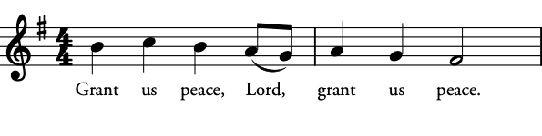
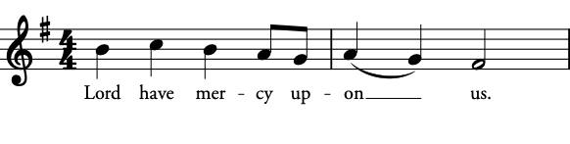


Grace Behrens
Violin
Madeline Hornsey
Violin
Emily Maher
Cello
Guest Instrumentalists

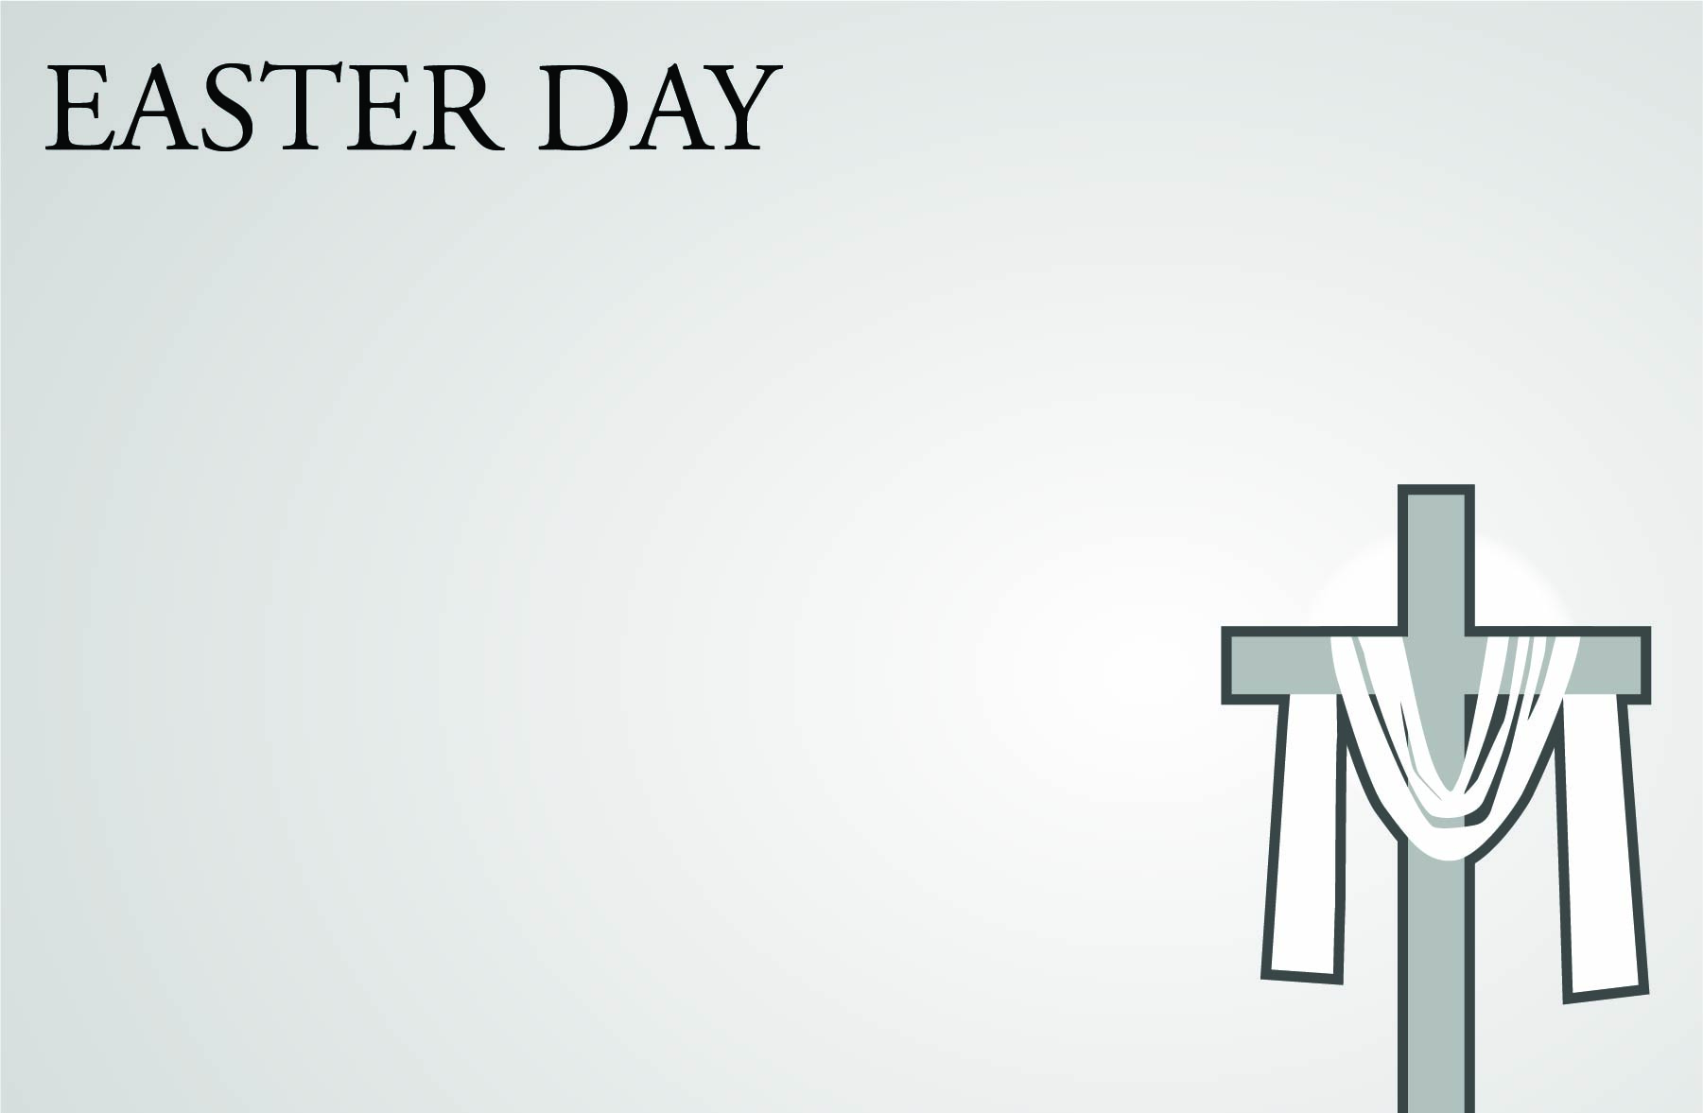
Early Christian pilgrims to the Holy Land often made it a practice to visit the places of Jesus' Passion. Stations of the Cross imitates this practice, beginning in the Garden Chapel and traveling around the front lawn to end in front of the Great Hall. At each station you will participate in a liturgy that highlights Christ’s passion.
Join us at 11:30 am or 6:30 pm tomorrow.
Good Friday is the solemn remembrance of Christ's death on the Cross. The service includes the reading of the Passion Gospel from John, the Solemn Collects, a Good Friday sermon, and concludes with veneration of the Cross.
Join us at 12 noon (also online) or 7 pm tomorrow.

The Great Vigil of Easter - (Saturday) 8 pm
The ancient and beautiful sung service of Easter that moves from darkness into the light of the Resurrection, beginning in the Garden Chapel and moving into the Great Hall. Join us this Saturday..

Easter Sunrise - 6:30 am at the Garden Chapel
With a simple liturgy and music, this beautiful service will begin while it is mostly dark and end in the full brightness of Easter morning. The Easter Sunrise service takes place at the outdoor Garden Chapel (on the front lawn). In case of rain, service will move to the Great Hall.

The Great Easter Egg Hunt - 10 am (between services)
The “Great Hunt” will hop into action at 10 am in the front lawn. Don’t forget to bring your Easter baskets to collect all those eggs!

Easter Day Services - 8 am, 9 am and 11 am
The joy-filled celebration of Christ’s resurrection on Easter morning.

Welcome

Have questions about our worship or St. Andrew’s? Feel free to contact Father Andrew or Father Logan at the contact information listed below.

Our worship is made possible each week by the faithful service of the members of our Altar Guild, directed by Chris Pappas, and made beautiful by the work of our flower guild, directed by Laura Verinder.
The text of the service of worship contained in this program is taken from the Book of Common Prayer 1979. The Book of Common Prayer alone is of authority in the worship of the Episcopal Church. This program is provided for convenience of use on this occasion. CCLI License No. 2626819
St. Andrew’s Staff & Vestry
The Rev. Andrew Van Kirk
Rector
andrewv@standrewsmckinney.org
The Rev. Logan Hurst
Vice Rector
loganh@standrewsmckinney.org
The Rev. Paulette Magnuson
Priest Associate
pwmagnuson@gmail.com
The Rev. Mike Klickman
The Rev. Gene Zeilfelder
Assisting Priests (Retired)
The Rev. Erica Andersen
Deacon, Curate
ericaa@standrewsmckinney.org
Tim Jenkins
Welcome and Communications Minister
timj@standrewsmckinney.org
Lisa Ostrowski
Outreach Minister
lisao@standrewsmckinney.org
Carolyn Nicketta
Office Administrator
carolynn@standrewsmckinney.org
Laura Bray
Children’s and Family Minister
and Music Director
laurab@standrewsmckinney.org
Michele Miller
Children’s Ministry Associate
michelem@standrewsmckinney.org
Stephanie Jenkins
Praise Band Leader
stephaniej@standrewsmckinney.org
Ned Searles
Senior Warden
Paul Miles
Junior Warden
Vestry
Eric Austin, Tracey Glenn,
Sandi Krummel, Paul Miles,
Diane Monk, Chinelo Onubogu,
Ned Searles, Peter Stringer,
Syd Verinder

